30-Minute Recipes to Increase Instructor Presence Using
Tools & Technology

Featuring technology and tools available to UF faculty and presented by the UFIT Center for Instructional Technology and Training
Shared as part of the UFIT Tech Byte presentation on August 22, 2022
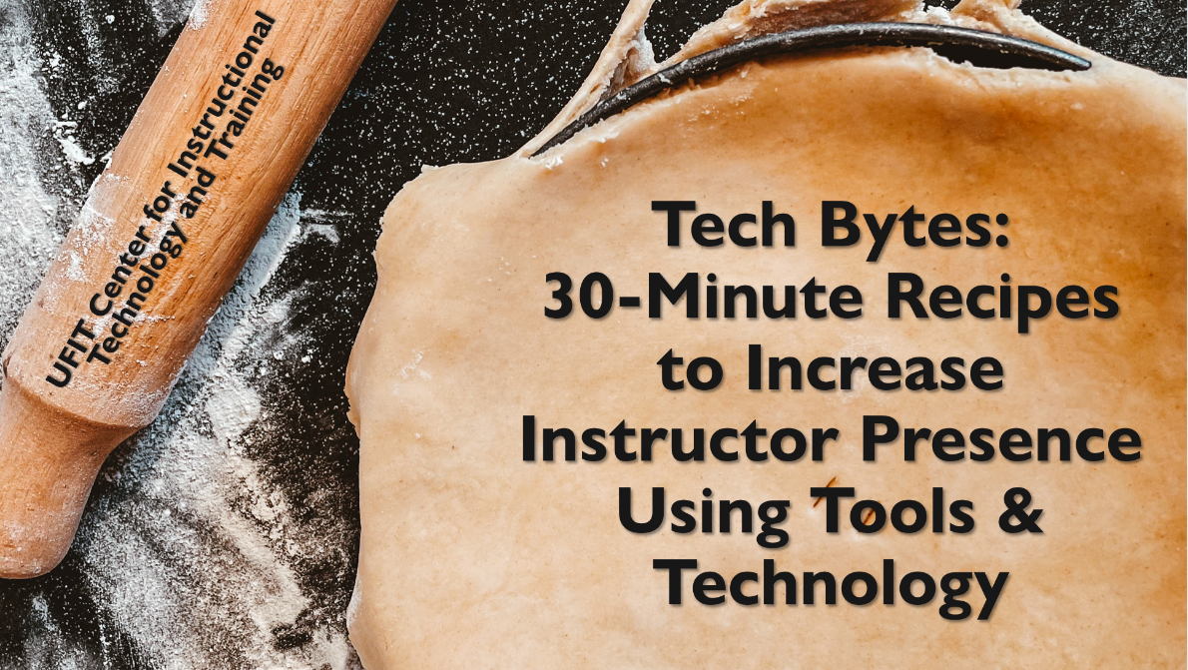
Contents
About this Document 2
“Get to Know You” Introduction and Word Cloud 3
Student Hour Appointments with Microsoft Bookings 5
QR Code 8
Feedback Survey 9
Start Here Module 11

About this Document
This document was compiled to exist alongside a UFIT Tech Byte presentation that covered several of the recipes that follow: 30-Minute Recipes to Increase Instructor Presence Using Tools & Technology (47:47). The presentation and “cookbook” were inspired by the chef Rachel Ray and her series of 30-Minute Recipe cookbooks.
Our goal was to identify relatively easy-to-use or familiar tools that could facilitate interaction and instructor presence in courses. We mention three dimensions of instructor presence: Persona, Social, and Instructional. This definition was inspired by Larry Ragan, director of instructional design and development for Penn State’s World Campus.
For assistance with these topics, or any other topic related to technology or teaching, please feel free to contact the UFIT Center for Instructional Technology and Training (CITT). We would be happy to assist you or direct you to someone who can best assist you!

Contact Information for UFIT Center for Instructional Technology and Training
Website: https://citt.ufl.edu/
Email: citt@ufl.edu
Location: Hub 2nd floor (please contact for appointment beforehand)

“Get to Know You” Introduction and Word Cloud

Purpose
Use a “Get to Know You” survey to increase your “Persona” presence in your course by sharing information about yourself and discovering commonalities among your class. The commonalities can be shared with a word cloud visualization! This recipe is designed for all class sizes and formats.

Summary
Adding an introductory survey to your course is a great way to connect your students interests and goals to your content. Asking questions like “What inspired you to enroll in this class?” “What academic and/or career goals do you have in this program?” and/or “What challenges or concerns do you anticipate this semester?” will help you personalize content and develop more meaningful relationships with students.
When including an introductory survey, add your responses to the same questions in the instructions so students have an opportunity to get to know you.
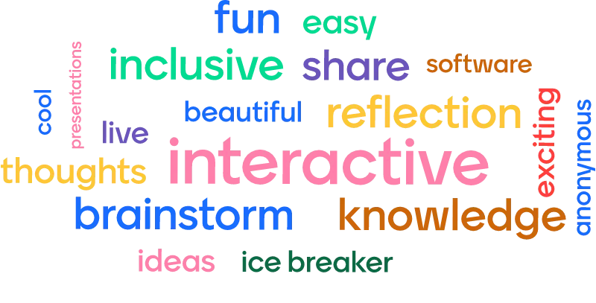
Using a classroom response tool like Mentimeter allows you to share a slide about yourself and gather responses from the class that can be displayed in a word cloud that shows emerging themes. This type of survey can be conducted in an asynchronous or synchronous environment with any class size. Alternatively, you can copy and paste survey results into a word cloud generator to create word clouds after the fact.

Ingredients
- Sharing your personal interests, passions, or objectives
- A “Getting to Know You” survey
  - Search for “University of Florida CITT Start Here Template” in Canvas Commons to find a template for a Getting to Know You Survey and other introductory activities.
- A word cloud generator or presentation tool like Mentimeter that can generate Word Clouds using live responses
  - Microsoft Forms can also generate word clouds using free response answers
- An announcement, an email, or a plan to share common themes and your word cloud in class

Recipe
Ready to share your “persona”, get to know your students, and then create a word cloud to share common themes in a class? Here are the steps!
- Using a PowerPoint slide, a Mentimeter slide, or your own responses to a “Get to know you” survey in Canvas or Microsoft Forms, let students learn a bit about you by answering the same questions that you will pose to them.
- Pose one or more questions to students that will allow you to better understand their concerns, interests, or goals this semester. For ideas, look to the “Summary” section above, the example word clouds linked in the resources below, or reach out to CITT.
- If using a tool like Mentimeter or Microsoft Forms, a word cloud is generated for you.
If you used a tool like a Canvas survey, responses could be copied and pasted into a word cloud generator so that it can pull out common words for you. Be sure to not paste in any sensitive or identifying information!
Alternatively, you could personally select common themes that you wish to share with the class and put them into a word cloud or “pin board” template of your choosing.
For accessibility, a count of each word used can be exported from the above tools to provide a quantitative and screen-readable format for the “weight” of the words in the word cloud.
- Share these common themes with your students in an announcement, in an email, or during class to demonstrate to students that you are interested in their responses and thoughts!

Additional Resources or Assistance
- Creating Welcoming Communities
- Email CITT to get help with a "Get to Know You" survey
- Email CITT to get help with Word Clouds
- 95 Word Cloud Examples & Questions + Templates - Mentimeter

Student Hour Appointments with Microsoft Bookings

Purpose
To remove barriers and provide opportunities to increase your “Social” presence, consider renaming office hours to “Student Hours” and using Microsoft Bookings to make it easier for students to schedule appointments.

Summary
By renaming Office Hours to “Student Hours”, you can make it clear that these times are focused on the needs of the students, not just times that you are in the office. In addition, student hours might not happen in the office, but could take place over platforms like Zoom. Student-centered language can encourage interactions between students and instructors, even outside the classroom.
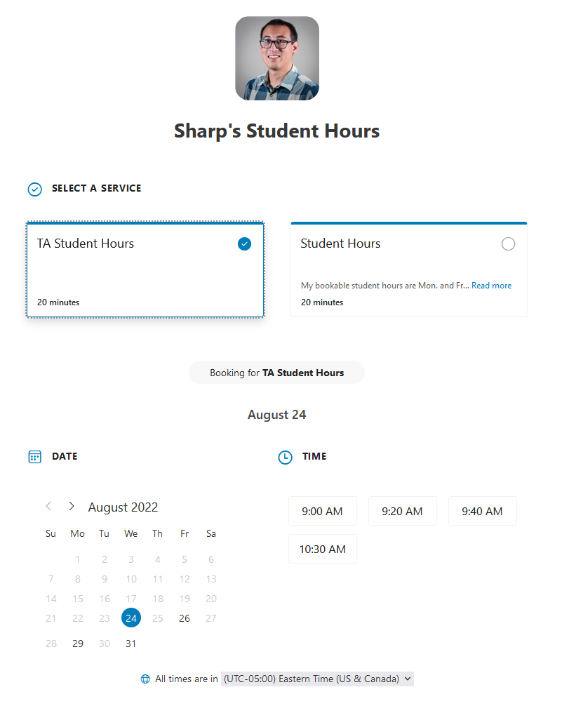
Students might struggle with anxiety when it comes to requesting appointments with faculty. Using a time booking tool removes a potential barrier between instructors and students, opening the door to more opportunities for interaction or mentoring. Booking tools also reduce the administrative time required to email and coordinate availability, especially if students are not able to attend regularly scheduled student hours.
Microsoft Bookings is also a great tool for advising appointments!

Ingredients
- Microsoft Bookings
- Outlook Calendar
- Places to add the Bookings link such as your syllabus, Canvas, and your office door
If you don’t like Microsoft Bookings, FreeBusy is also approved for use for UF business.

Recipe
Using Microsoft Bookings, you can create a page where students can select appointment options for student hours. Share a link to this booking page in your syllabus, on a Canvas page, or on your office door!
To see a final result, you can visit the pictured example booking page!
- Log in to Microsoft Bookings with your UFL account.
- Select +Create New Calendar.
- On the next four steps, follow the prompts:
  - Name your calendar, select “Education” as the business type, and leave the Business hours at its default.
  - You can invite others that may need access to this calendar, for example TAs. You can also choose to skip this step and add others later.
  - Skip this step by leaving the 30-minute meeting and updating the options for it later.
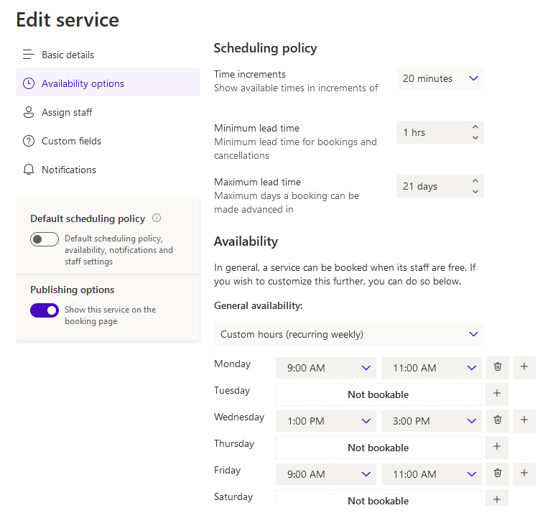
- Choose to either allow “Anyone” to book on a self-service page, or to require students to sign in with their UFL account by selecting “People in my organization”.
- In your new calendar, select “Services” from the left-hand menu to create a Student Hours service with available dates. You can add a new service or edit the existing “30-minute meeting” service.
- Check all the sections of the service, updating information when appropriate. Be sure to set the availability options to limit the days and times that students can reserve time with you.
- Select “Business information” to update your basic details and upload a picture, if desired.
- Select “Booking page” and copy the link. This link can be shared with students in a syllabus, in Canvas, or linked to using a QR code (see the next recipe for assistance with QR codes).
- Visit your booking page and review what you see to make sure that everything is set how you would like! If you want to block times that would normally be available, you can create “Busy” events in your Outlook calendar so that the Bookings app will know that you are not available at that time.

Additional Resources or Assistance
- Email CITT to get help with Bookings
- Microsoft Bookings help documents

QR Code

Purpose
Create scannable QR codes to make it easier for others to get to a particular webpage, especially when the address is complicated!

Summary
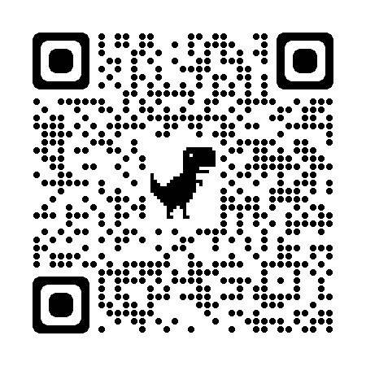
QR, or “Quick Response”, codes are scannable by most major phone brands and lets others avoid typing out long web page addresses. There are many ways to create QR codes, but you might already have software on your computer that lets you create them. Give this QR code a try by getting out your phone, opening your camera app, and pointing the camera at the code below.
Generating a QR code for a webpage is easy and allows you to have easy links to resources in a physical space. If you use Microsoft Bookings for student hours, for example, consider creating a QR code for the booking page and putting it on your office door or printed instructions! You could also use QR codes to provide links to resources and assistance for students on printed worksheets.

Ingredients
- Google Chrome or Microsoft Edge
- A printer
- The website that you want to share

Recipe
- Open the Microsoft Edge or Google Chrome browser
- Navigate to the desired page you want to share
- If using Chrome, click on the “Share this page” button in the address bar and select QR code. If using Edge, click on the “Create QR Code” button in the address bar. In Edge you can also right-click on a page and select “Create QR Code for this page” from the context menu.
- Click the “Download” button to save this QR code
- Insert this QR code into desired documents and print them out!

Please note that QR codes are not great for documents that are intended to be viewed on a computer screen, such as a Canvas page. In those situations, please use regular and accessible links. QR codes function best in places where the document is printed or is likely to be printed.

Additional Resources or Assistance
- Email CITT to get help with QR Codes
- Share pages with a QR Code with Google Chrome

Feedback Survey

Purpose
Use an online form or survey in Canvas to increase your “Instructional” presence and get feedback from students about their confidence in course content, opportunities to better assist their learning process, or insight into group dynamics and their emotional safety.

Summary
Creating ungraded forms or surveys to get feedback from your students is an easy process! There are many things that you can ask your students about to demonstrate that you are invested in their progress and increase your instructor presence. Do not overwhelm students with surveys, but here are a few ideas of topics that you might want to ask them about during your course:
- A “Stop, Start, Continue” survey – What should I stop doing, what should I start doing, and what should I continue doing to support the learning process?
- Group safety and emotional well-being – Are students safe and comfortable in their groups, are students able to participate in classroom activities without fear, and are there any problems that might need correction to make their experiences with your course better?
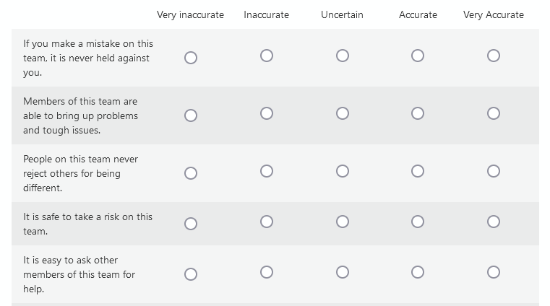
- Teaching Assistant (TA) feedback – Is the TA responsive to questions, are the student hours that the TA provides beneficial, and does the TA treat students with respect?

All of these surveys can increase your instructional presence for students and foster opportunities for interaction!

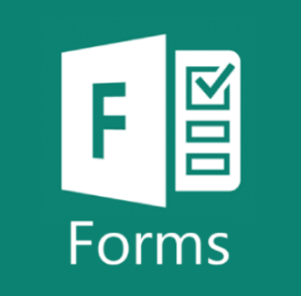
Ingredients
- Microsoft Forms
  - Alternatively: Canvas survey or Google Forms
- Survey questions
- A plan for limited sharing of the results so that students know their responses were read

Recipe
- Sign into Microsoft Forms using your UFL account, or sign into your alternative, approved survey tool.
- Either create a new Form (not Quiz), or open a link to one of the templates listed in the “Additional Resources or Assistance” section below.
- Add and edit the questions that you would like to pose to your students. Try to use positive language in your prompts, if applicable. Keep the survey short to make completion easy.
- In the Settings of the form, choose whether or not students must be signed into the organization (UFL) to complete the form, and whether or not their identifying information is automatically recorded by the form.
- Select “Collect Responses” and copy the link to the form. Share this link with students. Optionally, you can also shorten the link, generate a QR code for this form, or get an embed code that can be used in places such as a Canvas page.
- Review the results by clicking on the “Responses” tab. Be sure to address concerns and share a limited amount of information with the class to acknowledge their submissions.

Additional Resources or Assistance
- The Canvas “CITT Start Here” module (see the next recipe) has a “Stop/Start/Continue” and a “Getting to Know You” survey that can be imported into your course (refer to the Start Here module recipe in this cookbook)
- We have also created a few Microsoft Forms templates for your use. Click on a link to the form to create a duplicate:
  - Stop/Start/Continue
  - Confidential Group Safety survey
  - Anonymous Group Safety survey (same as above, but identifying questions are removed)
  - TA satisfaction survey
  - Getting to Know You form
- Email CITT to get help with Feedback surveys

Start Here Module

Purpose
A Start Here module introduces students to their instructor and the purpose and goals of the course. It also serves as landing place for UF Resources and Policies, instructional guides for course technology, and content that outlines how to be successful in the course.

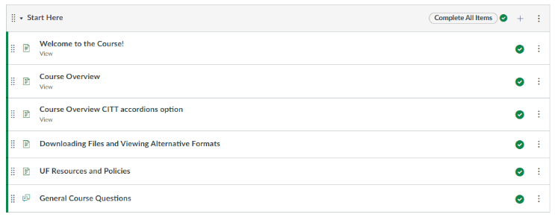
Summary
A Start Here module should be the first module students visit in your course. This module is an opportunity to welcome students to the course and typically includes the following pages:
- Welcome to the Course!
  - Instructor welcome video
  - Syllabus
  - Course Goals/Purpose
- Course Overview
  - Course description
  - About the instructional team
  - Course communication
  - Required texts and technology
  - Academic honesty information
  - Feedback and concerns
- How-to Guides for Navigating Course Technology (e.g., Downloading Files and Viewing Alternative Formats in Canvas, VoiceThread Guide)
- UF Resources and Policies
- General Course Questions
- Getting to Know You survey (see recipe in this cookbook)

Ingredients
- Build your course using Modules in Canvas
- Start Here module template (Import the Start Here module template by navigating to Canvas Commons and searching “University of Florida CITT Start Here Template”

Recipe
- Log in to eLearning at elearning.ufl.edu.
- Click on the Canvas Commons icon in the blue left-hand side navigation.
- Search University of Florida CITT Start Here Template and click to open.
- On the right-hand side, click Import/Download and select your course.
- Once imported, navigate to your course, and edit the existing content to reflect your course; delete what is not relevant.

Additional Resources or Assistance
- Request assistance to work with an instructional designer
- Email CITT to help with Start Here modules
- Connecting with Students

